Unit: Evolution NAME: Pd:

Evidence for Evolution Lab Activity

BACKGROUND
Much evidence has been found to indicate that living things have evolved or changed gradually during their natural history. The study of fossils as well as work in embryology, biochemistry, and comparative anatomy provide evidence for evolution.

OBJECTIVE
In this activity, you will learn about three evolutionary relationships: homologous structures, analogous structures and vestigial structures and their significance in evolution theory.

MATERIALS
Colored pencils

PROCEDURES AND OBSERVATIONS

Part I. Homologous Structures (See Figure 6 p.425)

Carefully examine the drawings of the bones of the six animals’ front limbs shown in the figure below. Note similar positions of similar bones.

- There are 6 different bones/bone groups: humerus, radius, ulna, carpals, metacarpals, phalanges. (See page 941 in the Zebra biology book or page 134 in Hole’s Essentials to identify the different bones of the human arm.) Color each bone (or bone group) of the human arm a different color. Phalanges (finger bones) are labeled with numbers (1=thumb, 5=pinkie) but can be colored all the same color. Then color the homologous bone in each of the other animals the same color as the human bone.
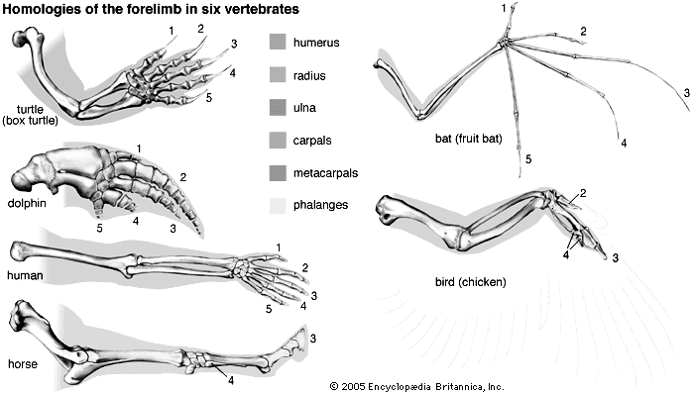

Color | Bone Name
Blue | Humerus
Red | Radius
Green | Ulna
Yellow | Carpals
Orange | Metacarpals
Purple | Phalanges

Homologous structures are formed in similar ways during embryonic development and share similar structural arrangements; however, they have somewhat different functions. Homologous structures and are evidence of divergent evolution.

2) Describe below the function of each animal limb that you colored:
Animal | Function
Human | Ex: Used for climbing, grasping, using tools.
Dolphin

Turtle

Bat

Bird

Horse

3) Describe how the bones are arranged in a similar way in each animal. ________

PART II. Analogous Structures (See Fig. 7 p.426)

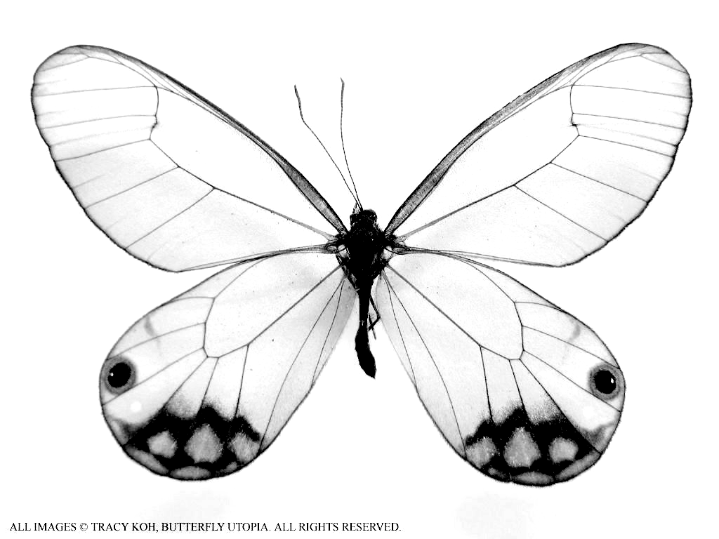
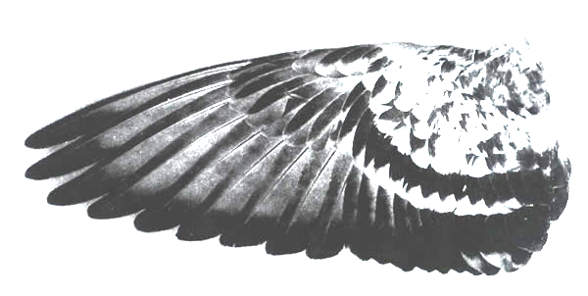
Examine the insect butterfly wing and the vertebrate bird wing shown in Figure 2.

- What is the purpose/function of these wings?
- List 3 ways the wings differ in structure.
_
bird wing butterfly wing
- Based on the structure of the wings of the bird and the butterfly would you suggest they are closely related species? Explain: _
Some apparently unrelated animals have structures with similar functions, yet are very different in structure and form. These structures are called analogous structures and are evidence of convergent evolution.

PART III Vestigial Structures (See Table 2 p.425)

Gradual changes have occurred through time that have in some cases reduced or removed the function of some body structures and organs. The New Zealand kiwi-bird’s wings and leg bones of snakes are examples of this phenomenon.

- The cave fish and minnow shown in Figure 3 are related, but the cave fish is blind (it has no functional eyes).
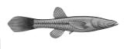
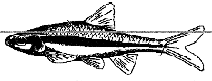
- Explain why eyesight is not an important adaptation to life in a cave.

- In what ways does the appearance of the cave fish and minnow suggest common ancestry?
Organs or structures that have lost their function in the organism and/or become reduced in size (because of efficiency) are called vestigial structures and are evidence of divergent evolution. Human vestigial organs are well documented.

- Read the list of human vestigial structures shown below.

- Internet research the following human structures. Suggest a possible function for each and explain why the structure became or could become vestigial in the future. Record your answers in the table.
Structure | Probable Function In Some Animals | Why Vestigial in Humans?
appendix
coccyx
muscles that
move ears
piloerector muscles
little (pinkie) toe
wisdom teeth
ANALYSIS AND INTERPRETATIONS

1. Explain why the homologous structures in Part I are evidence of common ancestry.

2. What type of evolutionary relationship is shared between the fin of a fish and the flipper of a dolphin (an aquatic mammal). Explain.

3. Use your textbook or the Internet to identify and describe two examples of homologous structures found in nature not previously mentioned/listed in this lab. For example: “The front limbs of terrestrial vertebrates is one example. The bones of each limb are positioned in the same order for each animal but they have different functions.” Provide two other examples.
Ex. 1)
Ex. 2)
4. Use your textbook or the Internet to identify two examples of analogous structures found in nature not previously mentioned/listed in this lab. For example: “The bird wing and the butterfly wing is one example. The wings have similar function but differ completely in structure/anatomy.” Provide two more examples.
Ex. 1)
Ex. 2)

5. Use your textbook or the Internet to identify two examples of vestigial structures found in nature not previously mentioned/listed in this lab. For example: “The eyes on a cavefish is one example. The eyes are present but the cavefish lives in complete darkness therefore the eyes are blind and serve no adaptive function.” Provide two more examples.
Ex. 1)
Ex. 2)

